**Professional Growth Booklet**

**2023-24**

**Paper version**

|  |
| --- |
| **Please add your name here:** |

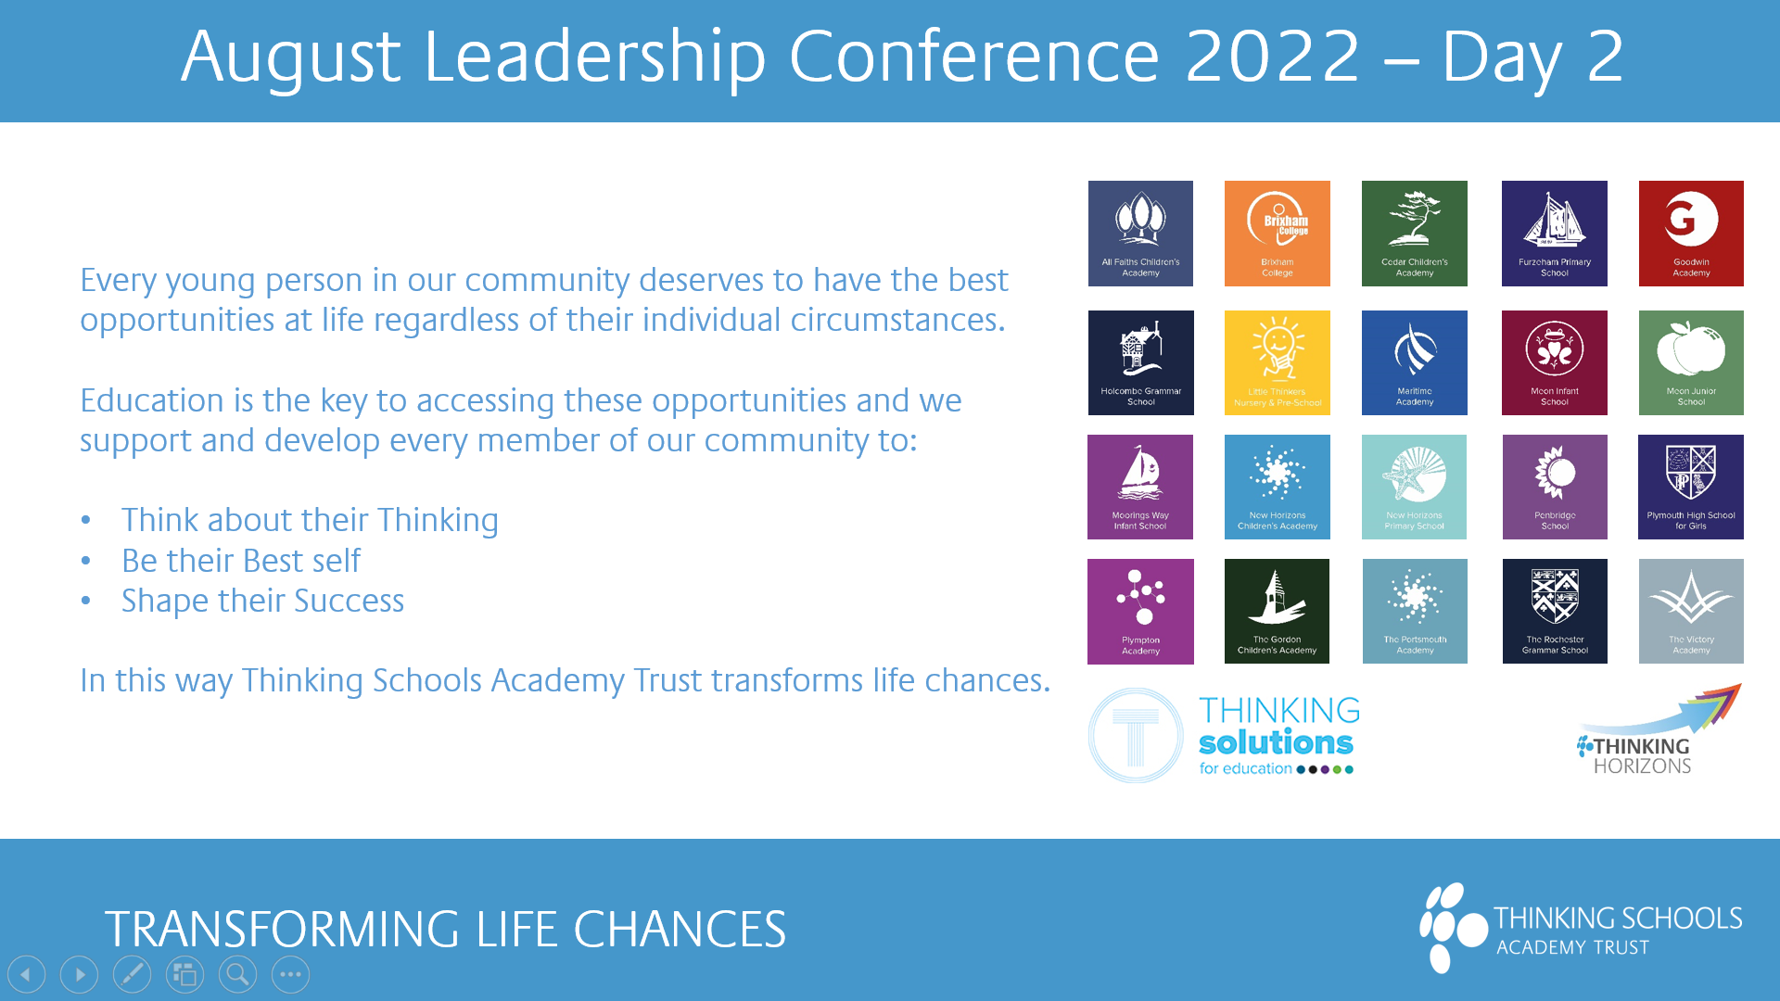

**Welcome to your Professional Growth Guide for 2023-24**

For those of you who embarked upon your professional growth journeys last year, the Think Ahead approach will be familiar to you. If you are new to our Professional Growth model, you will notice that things may be different to what you are used to.

**What’s in this booklet?**

Contents

What is Professional Growth? 3

Thinking Back to 2022-23 4

Review Statement 10

Thinking Ahead to 2023-24 11

Reviewers 11

OBJECTIVES PLANNING SHEET 12

Thinking Ahead to 2023-24 13

Check-ins 15

What does a good Check-in look like? 15

Check-in 1-15 16

Final thoughts…. 23

Appendix 1 – Objectives checklist for support staff 24

Appendix 2 – Professional Growth Assessment Framework 25

Appendix 3 - FAQs 26

# What is Professional Growth?

It may sound like it could just be a new name for Performance Management (PM) but fundamentally it is not.

As you will likely know, one of our core principles is to **Be Your Best Self** – to do this it is important that you feel that you have more autonomy over your objectives and an opportunity to deepen your skills in areas that you are passionate about. You could compare Professional Growth to a tree - growth can be upwards or outwards for those that want this but can also be about putting roots down to master skills in key elements of your role.

Staff feedback showed us that the old PM process just was not helping you do that. The process felt **complex, controlled, often irrelevant** and many staff felt they had to prove they were doing their day job – often having to collate large volumes of evidence to demonstrate that.

As a result of the above, we shifted our approach to enable you to have **more control** over where you think you can make the **biggest difference** in your role, wherever that is in the Trust.

**What has Changed?**

There are some similarities to PM, but also some **key differences**. This guide will go into more detail on the key areas you need to know about, as well as signpost you to our new Objectives Bank.

|  |  |  |
| --- | --- | --- |
| **What** | **Professional**  **Growth** | **Performance Management** |
| 3 Objectives for all staff | Yes | No |
| Proposed by staff member | Yes | Generally, no |
| Aligned to overall Trust, School or Department objectives | Yes | Yes |
| Same system used to log objectives for all staff | Yes | No |
| Objectives and other key information accessed via Teams account with single sign in | Yes | No |
| Objectives to be set by 31st October | Yes | Yes |
| Regular reviews & feedback on objectives through year | Yes | Generally, no |
| Mid Year check-in reviewed | Yes | Yes |
| Self-reviews against Teaching Standards mandatory | No | Yes |
| End year review for 2022/23  End year review for 23/24 | Yes  Based on check-ins across the year | Yes  Yes |
| Objective outcomes linked to pay | Yes | Yes |
| Different expectations dependant on level or experience | Yes | Yes |

# Thinking Back to 2022-23

If you are a school new to TSAT, you will need to complete your review according to your school’s Performance Management policy for 2022-23. Your Headteacher or Manager will provide you with instructions.

If you are a new member of staff who was not working for TSAT in 2022-23, you do not need to complete the review.

|  |  |  |  |  |  |  |
| --- | --- | --- | --- | --- | --- | --- |
| **To complete the reflection on 2022-23**  **Looking back**  *This section enables you to reflect upon your professional growth for 2022-23.*  **Recognition you have received over the last school year**   * Please add any feedback that you have received and from whom  |  | | --- | |  |   **What have been your biggest achievements this year?**   * What Went Well?  |  | | --- | |  |   **What could have gone better?**   * Even Better If?  |  | | --- | | Explain any barriers to your success |   **What plans went ahead?**   |  | | --- | |  |  * What next? What would you like to continue to practice and continue into 2023-24?  |  | | --- | |  |   **Objective 1 Reflection: Impact on Trust**  State here your first objective from 2022-23   |  | | --- | |  |   **What progress was made with this objective since the start of the cycle/ since the mid-year review reflection?**  **Minus: What challenges did you face in working on this objective? Is there anything you would have liked to have done further?**  **Interesting: What will you take from your work on this objective into your practice in 2023-24?**  *Would you consider yourself to have completed this objective fully?*  *Comments*  *If you answered no above, what % complete will you end the year on?* |
| **Objective 2 Reflection: Impact on Others**  State here your second objective from 2022-23   |  | | --- | |  |   **What progress was made with this objective since the start of the cycle/ since the mid-year review reflection?**  **Minus: What challenges did you face in working on this objective? Is there anything you would have liked to have done further?**  **Interesting: What will you take from your work on this objective into your practice in 2023-24?**  Would you consider yourself to have completed this objective fully?  Comments  If you answered no above, what % complete will you end the year on? |
| **Objective 3 Reflection: Impact on Self**  State here your third objective from 2022-23   |  | | --- | |  |   **What progress was made with this objective since the start of the cycle/ since the mid-year review reflection?**  **Minus: What challenges did you face in working on this objective? Is there anything you would have liked to have done further?**  **Interesting: What will you take from your work on this objective into your practice in 2023-24?**  *Would you consider yourself to have completed this objective fully?*  *Comments*  *If you answered no above, what % complete will you end the year on?* |

Reflecting on your objectives and progress this year, do you wish to add anything further to be considered by your reviewer? If Yes, please provide details

Please include details of any professional support you received or actions you took, since your interim review, to enable you to be successful.

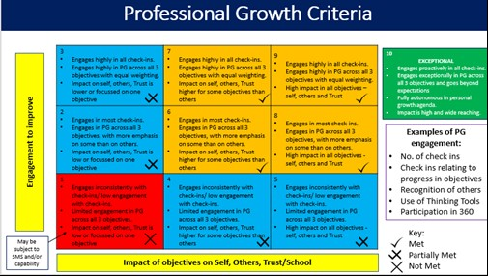

From the Professional Growth Framework, what score would you give yourself at year end (1-10) See numbers in top left of each box in framework.

**Your engagement**

How often do you submit your fortnightly check-in on time?

Never/Rarely/Sometimes/Often/Always

How fully are you meeting the requirements as detailed in your job description?

I am not/Some/Many/Majority/All

**Self-Assessment**

By taking into account progress against objectives, which of the following criteria have you met at year end

|  |  |  |  |  |  |
| --- | --- | --- | --- | --- | --- |
| ***Exceeded*** *your professional growth expectations for 2022-23 (exceptional performance)*  ***Met*** *professional growth expectations for 2022-23*  ***Partially met*** *professional growth expectations for 2022-23*  ***Not met*** *professional growth expectations for 2022-23* | *Tick one*   |  | | --- | |  | |  | |  | |  | |

Once you have completed the reflection, please pass your booklet to your line manager (it is a good idea to take a copy of the relevant pages for yourself at this stage).

**Please note, as this is your final review, you should then arrange a face-to-face meeting with your reviewer (where possible) to discuss your reflection before they write their final statement, and to discuss your objectives.**

# Review Statement

Your line manager will write your review statement once you have completed your reflection below:

|  |
| --- |
| Name of Reviewee: |
| Name of Reviewer: |
| Date of Review: |

|  |
| --- |
| Review statement to be added here: |

Reviewer to select one of the following statements (please tick only one that applies)

|  |  |  |  |  |  |
| --- | --- | --- | --- | --- | --- |
| *By taking into account your progress against your objectives, the way in which you have met the requirements of your job description as well as the relevant standards for your role, my recommendation is that you have:*  ***Exceeded*** *your professional growth expectations for 2022-23 (exceptional performance)*  ***Met*** *professional growth expectations for 2022-23*  ***Partially met*** *professional growth expectations for 2022-23*  ***Not met*** *professional growth expectations for 2022-23* | *Tick one*   |  | | --- | |  | |  | |  | |  | |

If they feel as though you have met the criteria for exceptional performance, managers will select the first statement above (exceeded). Headteachers/Managers will make the final decision on all Professional Growth outcomes.

***All professional growth reflections, reflection meetings, review statements and objectives must be completed by 31st October 2023***

# Thinking Ahead to 2023-24

# Thinking Ahead to 2023-24

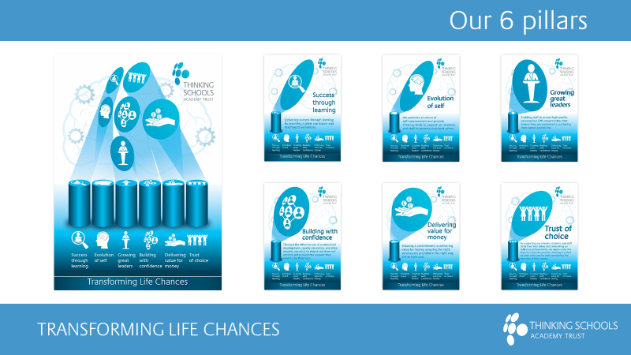Its key for staff to understand the Trust priorities for 2023-24 which fall into the following 6 pillars

**More Detailed priorities under each pillar are detailed below**

**Priorities**

1. To focus on a period of consolidation
2. To ensure that a culture of staff wellbeing is at the heart of our people strategy
3. To develop our use of data to inform decision making and intervention
4. To look at a more systematic way of working across all layers of the Trust

|  |  |  |
| --- | --- | --- |
| **Pillar 1** |  | |
| Consolidation | | 1a) Ensure all our schools are on their Thinking Journey to develop the common language between our schools.  1b) Roll out of further common resource areas across core subjects |
| Culture | | 1c) Re-establish our curriculum leaders to work closely together to share best practice and expertise |
| Data | | 1d) Improve KS2 and KS4 outcomes by developing effective intervention strategy to support the use of the Education drive team |
| Systems | | 1e) Review and update the Trust digital learning strategy to support effective deployment of resources to maximise impact on teaching and learning  1f) Ensure we have a systematic way to develop the memory agenda across all our schools, with effective use of knowledge banks and other systems to support this |
| **Pillar 2** |  | |
| Consolidation | | 2a) To develop the skills and knowledge of the team to ensure we can support Special resource provision (SRP) and Alternative provision (AP) settings through the use of external SLAs  2b) Further develop the BYBS journal to enable greater differentiation and a journey towards a mastery model |
| Culture | | 2c) To build on the coaching model and roll out wider to support the Trusts ambition to secure ‘Coach Mark’ status |
| Data | | 2d) Work to develop the impact of professional growth objective to ensure that the practice is as per policy  2e) To track effectively the Total Education offer we have in place across our schools |
| Systems | | 2f) To enrol some of our schools, if identified appropriate, on to the Behaviour Hub programme and share best practice across the Trust |
| **Pillar 3** |  | |
| Consolidation | | 3a) To relaunch Thinking Horizons and the CPD offer we have for all staff across the Trust including the various in-house options for all staff development |
| Culture | | 3b) Lead on the year 1 drive for ‘Investors in People’ ensuring that our leaders are equipped to support the delivery of the new People strategy with a focus on inclusive leadership |
| Data | | 3c) Use of data from the “Wellbee” system to support leaders to create schools and departments that promote the values of the Trust |
| Systems | | 3d) To embed the new HR recruitment system so that school leaders have access to real time information and talent pools  3e) To develop CPD tracking and evidence system to support links to Think Ahead |
| **Pillar 4** |  | |
| Consolidation | | 4a) To launch the EDT and their regional representatives to support our schools with an aim to have a solid foundation for school support  4b) To hold an external Governance review and implement recommendations to ensure we have effective structures in place across the Trust |
| Culture | | 4c) To establish a culture of Executive School Review meetings to create a more structured process to review school performance including staffing measures  4d) To support a number of schools in their first year as TSAT schools to on-board effectively |
| Data | | 4e) To ensure that we have an effective data reporting strategy, including the use of heat maps, for leaders and governors  4f) To embed a new QA framework and ensure data from this process is used effectively |
| Systems | | 4g) To consider how the Single central network is working and consider the potential for future development  4h) To launch a new HR & payroll to reflect the size of Trust we are |
| **Pillar 5** |  | |
| Consolidation | | 5a) To ensure the roadmaps that have been used to support school improvement create an effective tool to manage the various workstreams involved  5b) To embed the regional staffing models and ensure they working effectively with their local schools |
| Culture | | 5c) To create the culture of demonstrating value for money explicitly through further work on the cost per pupil model for services  5d) To develop a culture across the Trust to seek opportunities to secure additional income through either commercial activities or seeking opportunities to secure grants. |
| Data | | 5e) To further develop the expectations around curriculum financial planning and create a ‘safety net’ school structure  5f) To use the school condition data to inform sustainability strategies for the estates plan |
| Systems | | 5g) To review the MIS used across the Trust following the pilot last year and develop a plan to move the Trust to a single system over time |
| **Pillar 6** | |  | |
| Consolidation | | 6a) Enhance and improve the various staff networks across the Trust from MAT meets, HTs, DHTs etc. | | |
| Culture | | 6b) To ensure that schools create a culture of wellbeing using the principles established within the “Wellbeing charter”  6c) Focus on the development of strategies and employee engagement to support recruitment and retention improvements that will enhance our employee value proposition | | |
| Data | | 6d) Develop and share case studies to show why TSAT and the impact we have | | |
| Systems | | 6e) To have a communication strategy that supports effective communication with internal and external stakeholders | | |

Staff can pick objectives that contribute to the 4 key themes of our Trust People Strategy or one of the 6 pillars above. The below table helps to map out the common priorities with each.

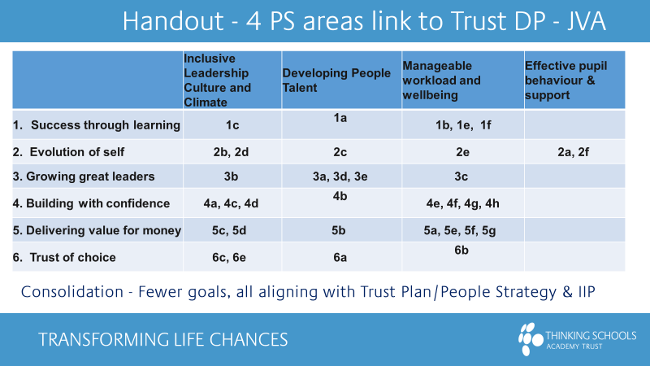

**Setting Your Objectives**

All staff, excluding ECTs who will not join the Professional Growth process until completion of their 2nd year, will be setting three objectives to work on through the year. These are themed to align with your School or for Central, Department, priorities as well as Trust foci.

In summary:

* **Impact on Trust** - this objective needs to link to one or more of the Trust Improvement priorities (known as the Trust pillars) that your Headteacher/ SMT member wants to focus on. Once selected, you will shape it into an objective that fits with your role/ function
* **Impact on Others** - this objective is around the impact you have on our students, pupils or staff, or, if in Central, our customers (using our Thinking Customer First Standards)
* **Impact on Self** - this objective is looking at your professional development in your role

On the TSAT website, under professional growth there is an [Objectives Bank](https://www.tsatrust.org.uk/wp-content/uploads/2021/09/TSAT-Objectives-Bank.xlsx) where you will find suggestions of key words or phrases you may want to use to ensure your objective is as clear as possible.

You will also find a checklist of key criteria (see Appendix) to help ensure your objective is appropriate for your experience and responsibilities.

**Whilst the number of objectives has been standardised across the Trust, we would expect the complexity and impact of objectives for more experienced or senior staff to be greater.**

**Questions to consider**

Alongside the key criteria outlined in the Objectives Bank you might find the following questions help you and your manager agree objectives.

* **Impact on Trust**

How does your objective support your school/ central department’s priority focus?

What would a 10/10 look like? How would you score yourself now?

What would move you up 1 point as your first priority?

How will this objective stretch you? What support do you need?

* **Impact on Others**

Who would benefit most from you making a change to the way you work?

How do you know this?

How will this objective stretch you? What support do you need?

How could your objective support your school/curriculum area/team focus?

* **Impact on Self**

What do you enjoy about your role?

Where would deepening your skills or knowledge be useful?

What will others notice about you when you’ve achieved this? What will be different to now?

**Setting Your Objectives**

All staff, excluding ECTs who will not join the Professional Growth process until completion of their 2nd year, will be setting three objectives to work on through the year. These are themed to align with your School or for Central, Department, priorities as well as Trust foci.

An ‘Objectives Bank’ and a checklist of key criteria to help ensure your objective is appropriate for your experience and responsibilities is available through your line manager.

# Reviewers

Your reviewer will be your line manager unless other arrangements have been agreed with your Headteacher, Principal or SMT member. If you have been assigned a new line manager for 23/24 (and your previous line manager still works for TSAT), please ensure that you ask them to complete your document/review and return to HR. Your new line manager will then review your objective setting for 23/24 and discuss any amendments that may be needed.

# Coaching

**If already trained as a facilitator**, please see the following guidance to help you to construct your coaching objective: [How to create your Coaching Objective](https://www.tsatrust.org.uk/wp-content/uploads/2022/09/COACHING-PROFESSIONAL-GROWTH-OBJECTIVE.pdf). Training will be provided to launch the qualification and to enable you to support other line managers completing the qualification in your school/ department. If you have any questions, please contact Sophie Venables, Head of Thinking Horizons (our professional development department).

**If you are a line manager (not already trained as a facilitator),** you will need to complete this qualification at any stage during the next 2 years (you can select to do it in 2023-24 or 2024-25). It will become one of your objectives for the selected year. Please see the following guidance to help you to construct your coaching objective: [How to create your Coaching Objective](https://www.tsatrust.org.uk/wp-content/uploads/2022/09/COACHING-PROFESSIONAL-GROWTH-OBJECTIVE.pdf). Your school/department’s trained facilitator will provide further support where required. This links in with our Trust’s commitment to providing all staff with an accredited coach to aid in their professional growth reflection process, and supports our ‘Be reflective to be effective’ agenda.

# Thinking Horizons Careers Pathways

When setting your objectives, we recommend you also visit our Thinking Horizons career development opportunities pages to consider what support is available to you in developing your expertise.

[Thinking Horizons career pathways page](https://www.tsatrust.org.uk/work-with-us/thinking-horizons/)

& [Apprenticeships page](https://www.tsatrust.org.uk/work-with-us/apprenticeships/)

# OBJECTIVES PLANNING SHEET

**IDEAS FOR FOCI IN 2023-24**

***Note these in the relevant segment***

# Thinking Ahead to 2023-24

Propose your objectives here:

|  |  |
| --- | --- |
| **Objectives** | **Success Criteria – what will success look like? Target date/milestones.** |
| **Objective 1 – Impact on Trust** | **Add 3** |
|  |  |
| **Objective 2 – Impact on Others** | **Add 3** |
|  |  |
| **Objective 3 – Impact on Self** | **Add 3** |
|  |  |
| Manager to review objectives above and add additional comments.  Line Manager to indicate below if objectives above are robust and agreed as meeting requirements as per objective checklist.   |  |  | | --- | --- | |  | Agreed – Yes/No | | Objective 1 |  | | Objective 2 |  | | Objective 3 |  |   Where amendments are required amended objectives can be added below:   |  |  | | --- | --- | | **Objectives** | **Success Criteria – what will success look like? Target dates/milestones.** | | **Objective 1 – Impact on Trust** | **Add 3** | |  |  | | **Objective 2 – Impact on Others** | **Add 3** | |  |  | | **Objective 3 – Impact on Self** | **Add 3** | |  |  |   Manager to sign off on amended objectives above ________________________________ | |

Check Ins

* A key part of this process and one of the easiest ways to get more regular feedback, reflect and contribute towards your preparation through the year is to check in on the Think Ahead app. There is an expectation to do this once a fortnight from November. The check-in dates can be seen below:

|  |  |  |  |
| --- | --- | --- | --- |
| Date | Day | Trust dates 2023-24 | |
| 01/09/2023 | Friday | CPD day | Objective setting window opens |
| 15/09/2023 | Friday |  | Reflections on last year deadline |
| 30/09/2023 | Saturday |  | Deadline for reviewers to complete end of year process |
| 20/10/2023 | Friday | CPD day - Trust conference | Outcomes to be approved by HTs and with HR deadline |
| 30/10/2023 | Monday |  | Check in 1 opens |
| 31/10/2023 | Tuesday |  | Deadline of objective setting for 23/24 |
| 03/11/2023 | Friday |  | Check In 1 closes |
| 13/11/2023 | Monday |  | Check in 2 opens |
| 17/11/2023 | Friday |  | Check in 2 closes |
| 27/11/2023 | Monday |  | Check in 3 opens |
| 01/12/2023 | Friday |  | Check in 3 closes |
| 11/12/2023 | Monday |  | Check in 4 opens |
| 15/12/2023 | Friday |  | Check in 4 closes |
| 08/01/2024 | Monday |  | Check in 5 opens |
| 12/01/2024 | Friday |  | Check in 5 closes |
| 22/01/2024 | Monday |  | Check in 6 opens |
| 26/01/2024 | Friday |  | Check in 6 closes |
| 05/02/2024 | Monday |  | Check in 7 opens |
| 09/02/2024 | Friday |  | Check in 7 closes |
| 26/02/2024 | Monday |  | Check in 8 opens |
| 01/03/2024 | Friday |  | Check in 8 closes |
| 11/03/2024 | Monday |  | Check in 9 opens |
| 15/03/2024 | Friday |  | Check in 9 closes |
| 15/04/2024 | Monday |  | Check in 10 opens |
| 19/04/2024 | Friday |  | Check in 10 closes |
| 29/04/2024 | Monday |  | Check in 11 opens |
| 03/05/2024 | Friday |  | Check in 11 closes |
| 13/05/2024 | Monday |  | Check in 12 opens |
| 17/05/2024 | Friday |  | Check in 12 closes |
| 03/06/2024 | Monday |  | Check in 13 opens |
| 07/06/2024 | Friday |  | Check in 13 closes |
| 17/06/2024 | Monday |  | Check in 14 opens |
| 21/06/2024 | Friday |  | Check in 14 closes |
| 01/07/2024 | Monday |  | Check in 15 opens |
| 05/07/2024 | Friday |  | Check in 15 closes |
| 31/10/2023 | Tuesday |  | Objective setting window closes |

* As you know, we spend a lot of time working with our pupils / students to help them be more reflective through the use of Thinking Tools and other techniques so we know how valuable reflection can be. We know it works for them and does for us.
* Research shows feedback is at its most effective up to 72 hours after the event being fed back on.
* After 72 hours people begin to forget what they did/why they did it/ how they did it etc, making connection between feedback and future action harder.
* Feedback received more than 2 weeks after an event is 50% less likely to impact future behaviour.

# What does a good check in look like?

**The first thing to note is that whatever you write in your check-in can be pulled into your final review at the end of the year, so do make the most of this.**

* Try to make it as specific as possible – picture how helpful it will be to be able to scan through this for your reviews! Rather than ‘Was a good week’ trying adding why
* Don’t forget to praise people where prompted using @ followed by their name. This will provide a great Friday feel good factor!
* Spot where you are making progress on your objectives and note this.
* If you have time, add a bit more detail – what will be useful to read back?
* If you are short on time, include three key words to describe your progress in an area
* You do not need to do everything each fortnight – WWW & EBI can be alternated with objectives progress
* Give yourself a score out of ten – could be your skill or confidence level

# Check-in 1

|  |  |
| --- | --- |
| Name of person completing check-in |  |
| Name of reviewer/line manager |  |
| Date of completion |  |
| WWW (What went well) |  |
| EBI (Even better if) |  |
| What’s next? |  |
| What progress has been made against objective 1 (23/24) |  |
| What progress has been made against objective 2 (23/24) |  |
| What progress has been made against objective 3 (23/24) |  |
| Provide names of those you would like to praise/thank for a job well done over period of check-in |  |
| Reviewer’s response |  |

# Check-in 2

|  |  |
| --- | --- |
| Name of person completing check-in |  |
| Name of reviewer/line manager |  |
| Date of completion |  |
| WWW (What went well) |  |
| EBI (Even better if) |  |
| What’s next? |  |
| What progress has been made against objective 1 (23/24) |  |
| What progress has been made against objective 2 (23/24) |  |
| What progress has been made against objective 3 (23/24) |  |
| Provide names of those you would like to praise/thank for a job well done over period of check-in |  |
| Reviewer’s response |  |

# Check-in 3

|  |  |
| --- | --- |
| Name of person completing check-in |  |
| Name of reviewer/line manager |  |
| Date of completion |  |
| WWW (What went well) |  |
| EBI (Even better if) |  |
| What’s next? |  |
| What progress has been made against objective 1 (23/24) |  |
| What progress has been made against objective 2 (23/24) |  |
| What progress has been made against objective 3 (23/24) |  |
| Provide names of those you would like to praise/thank for a job well done over period of check-in |  |
| Reviewer’s response |  |

# Check-in 4

|  |  |
| --- | --- |
| Name of person completing check-in |  |
| Name of reviewer/line manager |  |
| Date of completion |  |
| WWW (What went well) |  |
| EBI (Even better if) |  |
| What’s next? |  |
| What progress has been made against objective 1 (23/24) |  |
| What progress has been made against objective 2 (23/24) |  |
| What progress has been made against objective 3 (23/24) |  |
| Provide names of those you would like to praise/thank for a job well done over period of check-in |  |
| Reviewer’s response |  |

# Check-in 5

|  |  |
| --- | --- |
| Name of person completing check-in |  |
| Name of reviewer/line manager |  |
| Date of completion |  |
| WWW (What went well) |  |
| EBI (Even better if) |  |
| What’s next? |  |
| What progress has been made against objective 1 (23/24) |  |
| What progress has been made against objective 2 (23/24) |  |
| What progress has been made against objective 3 (23/24) |  |
| Provide names of those you would like to praise/thank for a job well done over period of check-in |  |
| Reviewer’s response |  |

# Check-in 6

|  |  |
| --- | --- |
| Name of person completing check-in |  |
| Name of reviewer/line manager |  |
| Date of completion |  |
| WWW (What went well) |  |
| EBI (Even better if) |  |
| What’s next? |  |
| What progress has been made against objective 1 (23/24) |  |
| What progress has been made against objective 2 (23/24) |  |
| What progress has been made against objective 3 (23/24) |  |
| Provide names of those you would like to praise/thank for a job well done over period of check-in |  |
| Reviewer’s response |  |

# Check-in 7

|  |  |
| --- | --- |
| Name of person completing check-in |  |
| Name of reviewer/line manager |  |
| Date of completion |  |
| WWW (What went well) |  |
| EBI (Even better if) |  |
| What’s next? |  |
| What progress has been made against objective 1 (23/24) |  |
| What progress has been made against objective 2 (23/24) |  |
| What progress has been made against objective 3 (23/24) |  |
| Provide names of those you would like to praise/thank for a job well done over period of check-in |  |
| Reviewer’s response |  |

# Check-in 8

|  |  |
| --- | --- |
| Name of person completing check-in |  |
| Name of reviewer/line manager |  |
| Date of completion |  |
| WWW (What went well) |  |
| EBI (Even better if) |  |
| What’s next? |  |
| What progress has been made against objective 1 (23/24) |  |
| What progress has been made against objective 2 (23/24) |  |
| What progress has been made against objective 3 (23/24) |  |
| Provide names of those you would like to praise/thank for a job well done over period of check-in |  |
| Reviewer’s response |  |

# Check-in 9

|  |  |
| --- | --- |
| Name of person completing check-in |  |
| Name of reviewer/line manager |  |
| Date of completion |  |
| WWW (What went well) |  |
| EBI (Even better if) |  |
| What’s next? |  |
| What progress has been made against objective 1 (23/24) |  |
| What progress has been made against objective 2 (23/24) |  |
| What progress has been made against objective 3 (23/24) |  |
| Provide names of those you would like to praise/thank for a job well done over period of check-in |  |
| Reviewer’s response |  |

# Check-in 10

|  |  |
| --- | --- |
| Name of person completing check-in |  |
| Name of reviewer/line manager |  |
| Date of completion |  |
| WWW (What went well) |  |
| EBI (Even better if) |  |
| What’s next? |  |
| What progress has been made against objective 1 (23/24) |  |
| What progress has been made against objective 2 (23/24) |  |
| What progress has been made against objective 3 (23/24) |  |
| Provide names of those you would like to praise/thank for a job well done over period of check-in |  |
| Reviewer’s response |  |

# Check-in 11

|  |  |
| --- | --- |
| Name of person completing check-in |  |
| Name of reviewer/line manager |  |
| Date of completion |  |
| WWW (What went well) |  |
| EBI (Even better if) |  |
| What’s next? |  |
| What progress has been made against objective 1 (23/24) |  |
| What progress has been made against objective 2 (23/24) |  |
| What progress has been made against objective 3 (23/24) |  |
| Provide names of those you would like to praise/thank for a job well done over period of check-in |  |
| Reviewer’s response |  |

# Check-in 12

|  |  |
| --- | --- |
| Name of person completing check-in |  |
| Name of reviewer/line manager |  |
| Date of completion |  |
| WWW (What went well) |  |
| EBI (Even better if) |  |
| What’s next? |  |
| What progress has been made against objective 1 (23/24) |  |
| What progress has been made against objective 2 (23/24) |  |
| What progress has been made against objective 3 (23/24) |  |
| Provide names of those you would like to praise/thank for a job well done over period of check-in |  |
| Reviewer’s response |  |

# Check-in 13

|  |  |
| --- | --- |
| Name of person completing check-in |  |
| Name of reviewer/line manager |  |
| Date of completion |  |
| WWW (What went well) |  |
| EBI (Even better if) |  |
| What’s next? |  |
| What progress has been made against objective 1 (23/24) |  |
| What progress has been made against objective 2 (23/24) |  |
| What progress has been made against objective 3 (23/24) |  |
| Provide names of those you would like to praise/thank for a job well done over period of check-in |  |
| Reviewer’s response |  |

# Check-in 14

|  |  |
| --- | --- |
| Name of person completing check-in |  |
| Name of reviewer/line manager |  |
| Date of completion |  |
| WWW (What went well) |  |
| EBI (Even better if) |  |
| What’s next? |  |
| What progress has been made against objective 1 (23/24) |  |
| What progress has been made against objective 2 (23/24) |  |
| What progress has been made against objective 3 (23/24) |  |
| Provide names of those you would like to praise/thank for a job well done over period of check-in |  |
| Reviewer’s response |  |

# Check-in 15

|  |  |
| --- | --- |
| Name of person completing check-in |  |
| Name of reviewer/line manager |  |
| Date of completion |  |
| WWW (What went well) |  |
| EBI (Even better if) |  |
| What’s next? |  |
| What progress has been made against objective 1 (23/24) |  |
| What progress has been made against objective 2 (23/24) |  |
| What progress has been made against objective 3 (23/24) |  |
| Provide names of those you would like to praise/thank for a job well done over period of check-in |  |
| Reviewer’s response |  |

# July End of year reflection – separate template to be provided

# Final thoughts….

**“The challenge is to ALWAYS improve, to ALWAYS get better, EVEN WHEN YOU ARE THE BEST”.**

# Appendix 1 – objectives checklist for support staff

# Appendix 2 – Professional Growth Assessment Framework

# Appendix 3 - FAQs

**General**

* **Why are we changing to Professional Growth?**

Many organisations have changed the way they approach staff ‘appraisals’, or performance management (PM), over recent years as the more traditional approach is increasingly ineffective. We surveyed and interviewed a wide range of staff in our Trust and heard how the old PM process often felt irrelevant, impersonal, restrictive and was often largely forgotten about until just prior to reviews. Staff also fed back that they wanted more feedback on their performance through the year and to reduce the need to ‘prove’ they were doing their day job with lots of evidence. Our new approach offers staff more autonomy in the objective setting process as well as keeping these more live during the year through quick online check ins. You can read more about our approach in the Think Ahead Professional Growth Policy.

* **Isn’t Professional Growth just a new name for Performance Management?**

No, it really isn’t. The core principles of Professional Growth are to give staff more autonomy to decide what they are focussing on (aligned to the needs of the Trust), to encourage mastering of skills & knowledge (which may mean working on areas you are already good at but getting even better) and finally to encourage staff to really think about the purpose of their role (which allows you to focus on areas that should tap into why you do what you do!)

* **Who does Professional Growth apply to?**

All staff apart from ECTs (see below) – Teaching, Support and Central right through to the Exec Team.

* **Does Growth mean progressing upwards? Or taking on more responsibility?**

Not necessarily - whilst this may happen through your efforts and input this isn’t the only route through the Professional Growth journey. We’re just as keen that people have an opportunity to master skills in their existing roles to be even better at the as to apply for something new.

* **I’ve just started work at TSAT and am still on probation, does PG apply to me?**

Yes it does, you’ll need to agree your objectives when you join the Trust which will also be used to for your probation review. Your Manager will guide you around appropriate objectives at this stage of your career with us. Please see the Probation Policy for more details.

* **What does exceptional mean?**

As this is linked to a higher pay award it’s expected that the individual will frequently deliver high quality work over and above what’s expected at their level. Our Pay Policy which you can find on the Trust website outlines more fully what is meant by exceptional performance at our Trust. See below:

***Support staff*** *- Examples of high and wide-reaching impact • Professional Growth objectives are exceeded in all areas of self, others and Trust; • The requirements of the role were delivered exceptionally well and the requirements of the role were exceeded; • Very positive behaviours are displayed, e.g.: • Customers’ expectations frequently exceeded and/or exceptional customer service provided even when customer expectations could not be met; • Proactively engaging and motivating others; providing significant support to others (including colleagues and customers); • Consistently leading by example and acting as a role model or champion; • Taking into account the implications of their activities on own initiative; • Willingly taking on additional responsibilities outside role requirement*

Regular engagement in your professional growth and setting an example to others in this space is also key to achieving this level. Regular dialogue with your Manager around how you are progressing through the year should also help with a mutual understanding of your performance.

* **Do I still have to prepare and bring ‘evidence’ to my annual review?**

Think Ahead will help to highlight your progress to your manager over your year in full and spot key achievements or challenges more easily. You may wish to highlight where you feel you’ve gone over and above your responsibilities.

* **Will teaching staff be allocated time for ‘check ins’ from their Directed Time?**

Yes. Support and Central Staff should agree any time required with their manager. Check-ins should take approx. 10 mins to complete each month.

* **Is Professional Growth still linked to pay?**

Yes. Our approach to pay hasn’t changed. You need to fulfil the requirements of the ‘met’ part of the assessment grid on page 25 to be awarded pay progression. The green section of this framework links to exceptional performance, details of which you will already have seen above. The pay policy states:

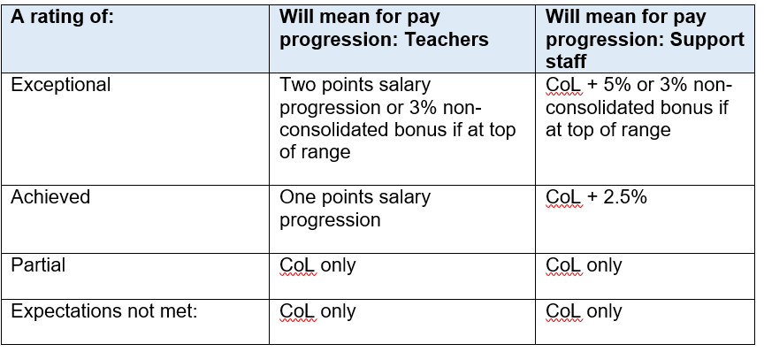

Not Met

Met

Exceeded

Partially Met

**Objective Setting**

* **How much flexibility do we have when setting our objectives?**

More than previously - we are very keen that staff identify areas that they would like to work on as opposed to generic objectives which have far less meaning. You will need to ensure that your objective links to the overall direction or focus of your area of the Trust, which is best practice in any organisation, and that it meets some key criteria linked to your level or responsibilities.

* **What should I consider when preparing my objectives?**

Please follow the guidance in our Think Ahead Professional Growth Policy. Give yourself time to reflect on how you have performed previously, what plans your team has and ensuring your focus is appropriately challenging for your role & experience will all be key to strong objectives.

* **What if my manager doesn’t agree with my objectives?**

TheObjectives Bank criteria should provide some guidance to help you talk through your rationale for the objectives you are proposing. We would expect your manager to provide some constructive challenge as part of agreeing your objectives based around your previous experience and responsibilities. Hopefully through discussion you’ll both agree on final objectives however if this doesn’t happen then you and your Manager should discuss this with their Manager who will agree the final version.

* **Can I change my objectives during the year if my circumstances change?**

Yes – however this should be agreed with your Manager and recorded in this booklet.

* **What do I do if I complete my objectives early?**

These should be marked as complete in this booklet and you should discuss with your Line Manager what else would be useful for you to focus on or what you could do further to help others.

* **Where can I find guidance on how to draft objectives?**

We have created an ‘Objectives Bank’ which is a resource to help staff identify and structure objectives for discussion with their Manager. Your line manager can talk you through this process.

* **What if I want to work on more than three objectives?**

This is fine if you would like to however you should make it clear which objectives you are prioritising for your review as these will be the ones that are reviewed with regards to your pay.

* **Can my objectives run over more than one year?**

You may identify a theme that you are deepening your skills around but you should be clear what your focus and outcomes are intended to be for the current year in order to track your progress. You may then decide that this is a key area to deepen your knowledge of or widen your impact in the following year.

* **As a Manager, what’s the expectation of me to respond to Check-ins?**

From our earlier work with staff, one of the key areas they’d like to see an increase in, is feedback on performance. Whilst you aren’t expected to comment on every response in a team member’s check in, we would expect you to acknowledge that you’ve seen it and add a comment on at least one response.